Java Exception Handling using try-catch

1. NullPointerException
public class NullPointerDemo {
public static void main(String[] args) {
try {
String text = null;
System.out.println(text.length());
} catch (NullPointerException e) {
System.out.println("Exception caught: " + e);
}
}
}
Output:
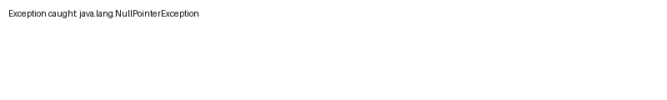

2. NumberFormatException
public class NumberFormatDemo {
public static void main(String[] args) {
try {
String value="ABC";
int n=Integer.parseInt(value);
System.out.println(n);
} catch (NumberFormatException e) {
System.out.println("Exception caught: " + e);
}
}
}
Output:
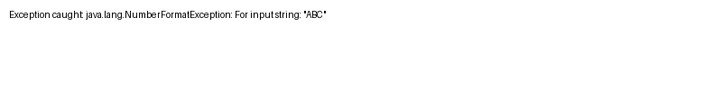

3. ArrayIndexOutOfBoundsException
public class ArrayIndexDemo {
public static void main(String[] args) {
try {
int[] arr={10,20,30};
System.out.println(arr[5]);
} catch (ArrayIndexOutOfBoundsException e) {
System.out.println("Exception caught: " + e);
}
}
}
Output:
